DIVISION

TEMPLATES AND GUIDESFG

The Division is migrating to a newer Network Management System. SNMPc will no longer be used from the Brigade level and below. PACSTAR IQ Core will be the new system. Ensure you use this document to add devices to your Management System.

1. Access your PACSTAR server through VirtualBox and Power on the VM.
2. Login using credentials that were provided.
3. Click on the IQ-Core icon on the Desktop.

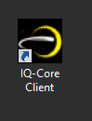

1. Login using the same credentials as the VM. Use the IP address of the VM and click Connect:

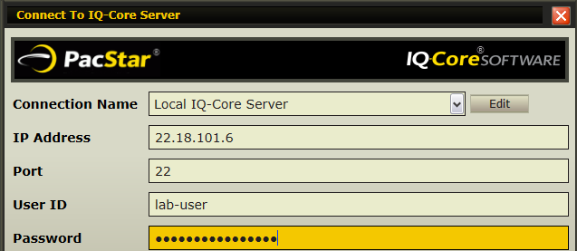

1. Click Finish once it say you have successfully login.
2. To add a device please refer the following file in the folder:
   1. PacStar IQ-Core Software Getting Started Guide (PacStar Proprietary, Copyright 2017).pdf starting at page 30.

**Creating a CUSTOM monitor for OSPF Neighbor state:**

1. From the Status Tab, click Customize:



1. Click Add and Select OSPF Neighbor:

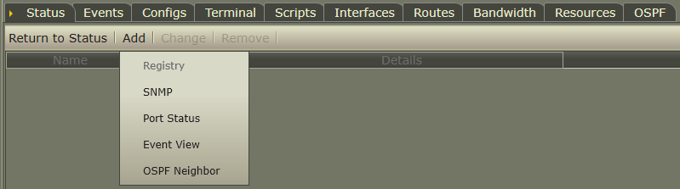

1. In the next window, Type a name for the Custom Monitor (ex.OSPFtoR16) and select the Neighbor IP you want to monitor then Click Next:

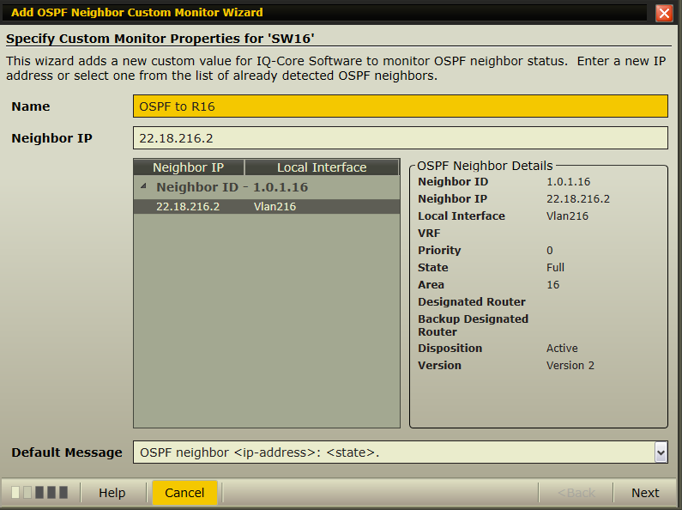

1. The Next window shows you the message the monitor will provide when OSPF is disconnect it is optional to check the Treatment and Alert boxes then click (Add Monitor) and Close:

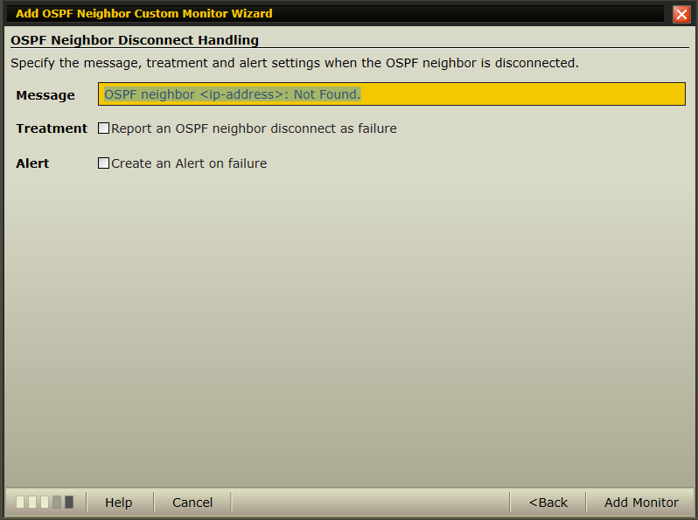

1. You should see the custom monitor configured:

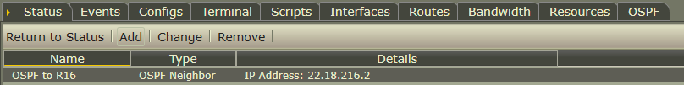

1. Click (Return to Status) to verify that the OSPF neighbor Monitor is functioning correctly.

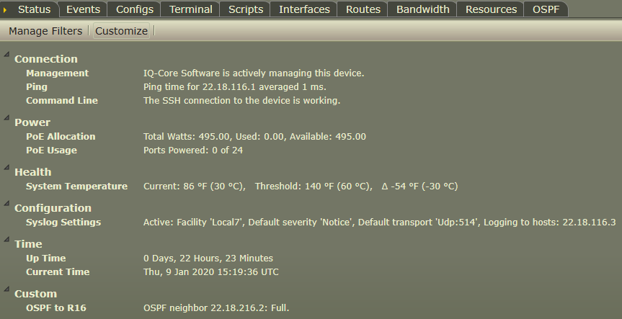

**Adding Devices to the Dashboard**

1. To add a device, please reference the PacStar IQ-Core Software Getting Started Guide (PacStar Proprietary, Copyright 2017).pdf starting at page 41. Also, the document shows you how to do an interface widget too.
2. To add an OSPF link status go to the Dashboard, Click on Edit, Click on Insert 🡪 Connection 🡪 Device State Connection: 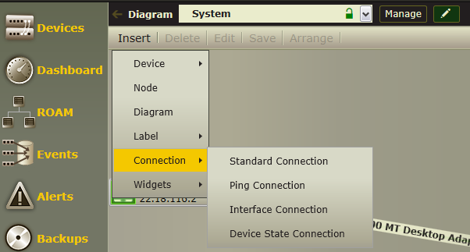

Edit

1. Click between to two devices where you want to link to show in the dashboard then Choose Custom and the Custom Monitor you would like to use then Next:

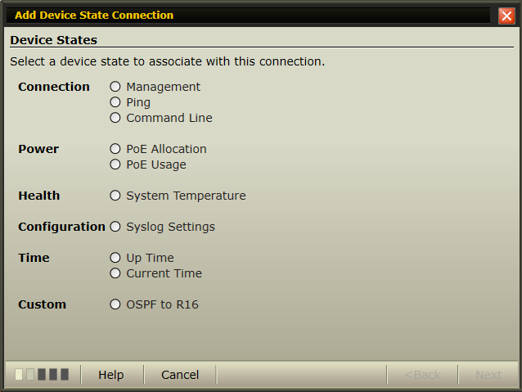

1. In the Display Option, you can select how you want to Arrows and Label to be represented on the Dashboard then Click Next:

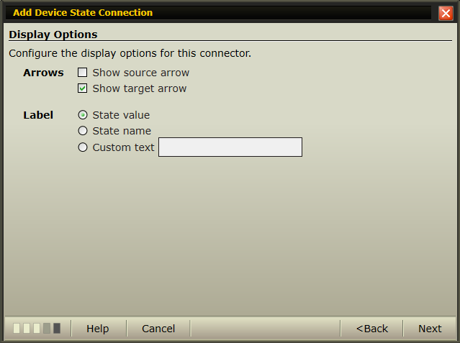

1. After verifying in the Summary, click Add:

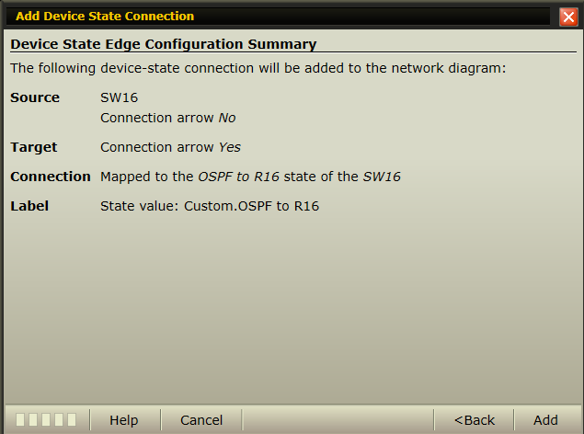

1. Once compete, the should look like the below figure:

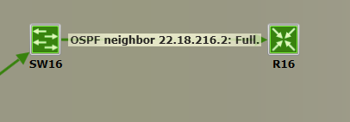

**Back Up a Device and Compare Configuration**

1. To Back Up a Device and Compare Configuration, please see PacStar IQ-Core Software Getting Started Guide (PacStar Proprietary, Copyright 2017).pdf starting at page 47.